Packaging Materials Industry

Shrushti Shakya

Iresh

Table Of Content
Executive Summary……………………………………………………….

Executive Summary

Chapter 1: Introduction
The packaging materials industry is one of the most important and rapidly growing sectors supporting global manufacturing, retail, logistics, food processing, pharmaceuticals, e-commerce, and consumer goods industries. Packaging materials are used for enclosing, protecting, preserving, storing, transporting, and marketing products while ensuring safety, quality, and convenience for consumers. The industry includes a wide range of materials such as plastic, paper, glass, metal, corrugated boxes, flexible packaging films, and biodegradable packaging solutions. In today’s competitive business environment, packaging is not limited only to product protection but has evolved into an essential business function that contributes to branding, marketing, customer satisfaction, and supply chain efficiency.
The packaging materials industry plays a crucial role in maintaining product quality and reducing damage during handling, storage, and transportation. Effective packaging enhances product shelf life, improves operational efficiency, and supports inventory management across industries. In addition, packaging serves as an important promotional tool through attractive designs, labelling, and brand identification, influencing consumer purchasing decisions and strengthening market presence.
The scope of the packaging materials industry is broad and continuously expanding due to rapid industrialization, urbanization, rising disposable income, changing consumer lifestyles, and the growth of organized retail and e-commerce sectors. Packaging materials are extensively used in industries such as FMCG, Food & Beverage, Pharmaceuticals, Cosmetics, Healthcare, Agriculture, Electronics, and Online Retail. The increasing demand for packaged food products, healthcare items, and online delivery services has significantly contributed to the growth of the packaging sector both in India and globally.
The packaging materials industry can be broadly classified into the following market segments:
- Plastic Packaging
- Paper and Paperboard Packaging
- Metal Packaging
- Glass Packaging
- Flexible Packaging
- Sustainable or Biodegradable Packaging
Plastic packaging is widely used because of its flexibility, durability, and cost-effectiveness, while paper-based packaging is gaining importance due to increasing environmental concerns. Metal and glass packaging are commonly used in beverage, cosmetic, and pharmaceutical industries because of their strength, safety, and recyclability. In recent years, sustainable packaging solutions have emerged as a key growth area as companies increasingly focus on reducing environmental impact and complying with government regulations related to sustainability.
Historically, the packaging materials industry has experienced consistent growth due to technological advancements, expansion of industrial activities, rising consumer demand, and globalization of trade. The rapid growth of e-commerce platforms, organized retail, and food delivery services has further accelerated the demand for innovative and durable packaging solutions. Technological developments such as automation, smart packaging, digital printing, and eco-friendly packaging technologies have transformed the industry and improved operational efficiency.
At present, the Indian packaging industry is considered one of the fastest-growing sectors in the economy. India has more than 22,000 packaging units, out of which nearly 85% are Small and Medium Enterprises (SMEs), highlighting the strong presence of small-scale manufacturers and regional packaging businesses in the industry. According to industry estimates, the Indian packaging market size is valued at USD 101.12 billion in FY 2025 and is expected to grow at a compound annual growth rate (CAGR) of approximately 10.73% in the coming years. The growth is primarily driven by increasing demand from FMCG, pharmaceuticals, food processing, cosmetics, and e-commerce industries. Rising consumer awareness regarding sustainable packaging and increasing adoption of recyclable and biodegradable materials are also expected to create significant growth opportunities for the industry in the future.
Major companies operating in the Indian packaging industry include UFlex Ltd., Huhtamaki India Ltd., EPL Ltd., Jindal Poly Films Ltd., Cosmo First Ltd., Mold-Tek Packaging Ltd., and TCPL Packaging Ltd..
Overall, the packaging materials industry plays a vital role in industrial growth, economic development, and supply chain management. With continuous advancements in technology, increasing focus on sustainability, and rising demand from various end-user industries, the packaging materials industry is expected to witness significant growth and transformation in the coming years.

Chapter 2: Industry Overview
  - Global Packaging Industry Overview
The global packaging industry is a crucial supporting sector for international trade, manufacturing, and consumer goods distribution. It plays an essential role in ensuring product safety, quality preservation, storage efficiency, transportation, and marketing across diverse industries such as FMCG, food and beverages, pharmaceuticals, healthcare, cosmetics, electronics, and e-commerce. Over time, packaging has evolved from a basic protective function to a strategic business element that supports branding, product differentiation, supply chain efficiency, and consumer engagement.
The industry is significantly influenced by global economic development, changing consumer lifestyles, increasing urbanization, and the rapid expansion of organized retail and digital commerce. The growing demand for packaged food products, ready-to-eat meals, personal care products, and online retail deliveries has further strengthened the global packaging market. Additionally, rising awareness regarding hygiene, product safety, and convenience has contributed to the continuous expansion of packaging consumption worldwide.
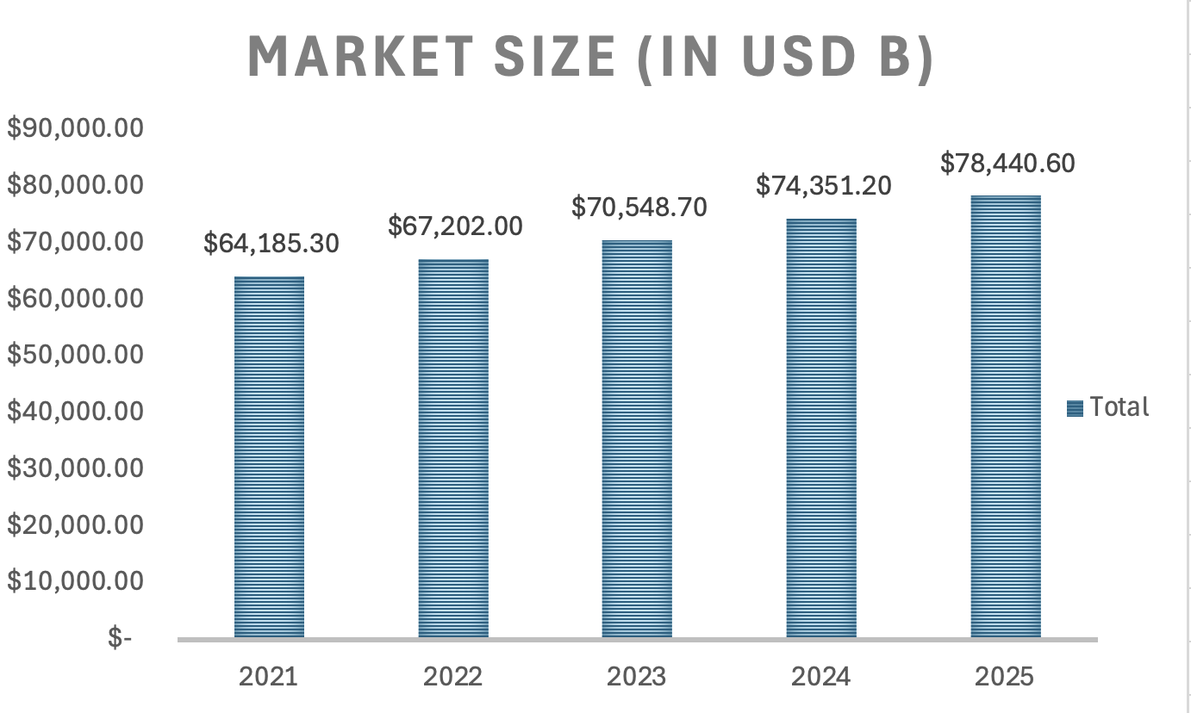
Source: Statista
According to Statista Market Insights, the global packaging industry has shown steady growth over the period 2021 to 2025. The market value increased from USD 64,185.30 billion in 2021 to USD 78,440.60 billion in 2025.

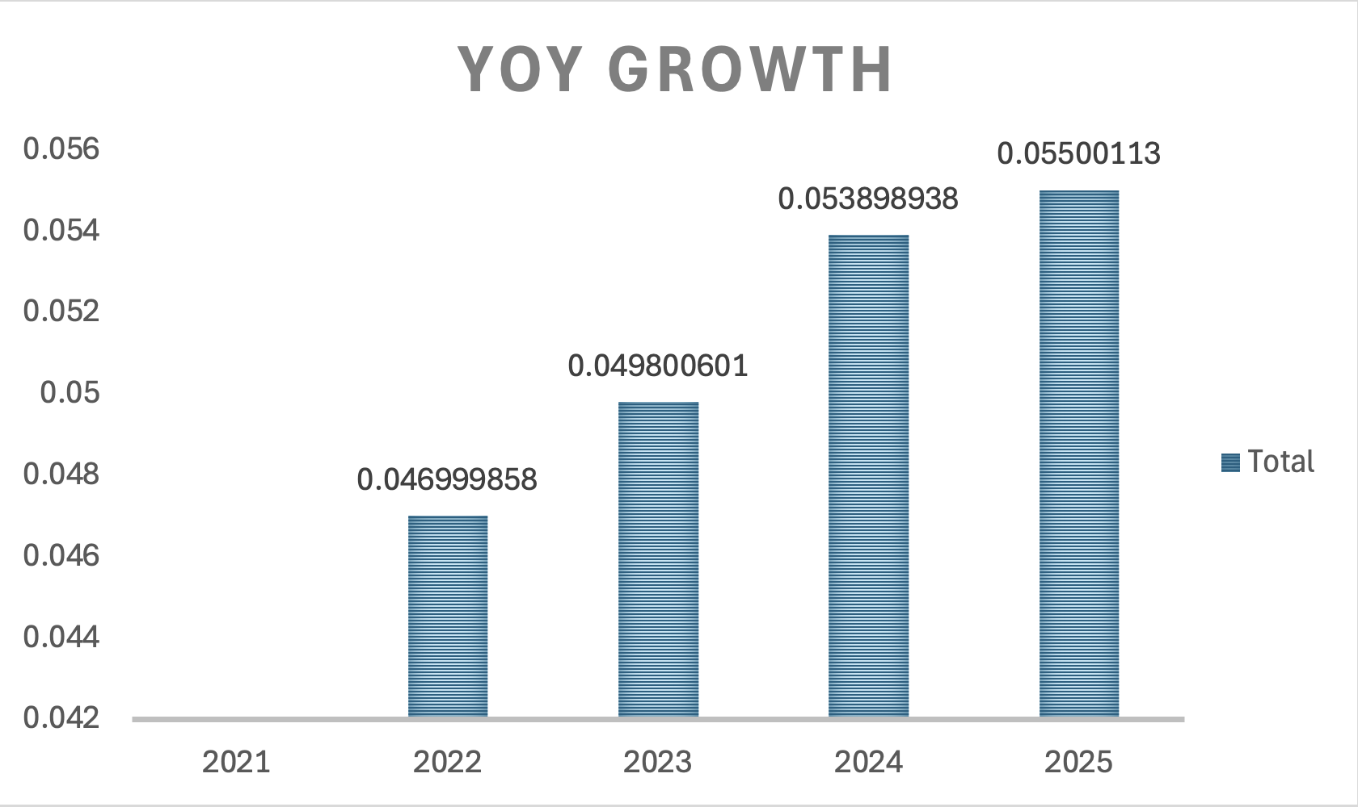
Source: Statista
It also reflecting consistent year-on-year growth. The industry recorded a CAGR of approximately 4.70% in 2022, increasing gradually to 5.14% in 2025, indicating stable and sustainable expansion. Overall, the sector has grown by nearly 22% during this five-year period, highlighting strong global demand and resilience.
The growth of the global packaging industry is primarily driven by the expansion of e-commerce and digital retail platforms, increasing demand for packaged and convenience food, rising consumption of pharmaceutical and healthcare products, and the development of global supply chain networks. In addition, the shift toward sustainability has become a major influencing factor, with companies increasingly adopting recyclable, reusable, and biodegradable packaging materials to reduce environmental impact and comply with regulatory standards.
Technological advancements are also transforming the industry, with innovations such as smart packaging, automation, digital printing, RFID tracking, and QR-based labelling improving efficiency, traceability, and customer engagement. Furthermore, the increasing popularity of flexible packaging due to its cost-effectiveness, lightweight nature, and ability to extend product shelf life is reshaping market dynamics.
Overall, the global packaging industry is experiencing steady and stable growth, supported by structural demand from multiple end-use sectors and continuous technological innovation. With a CAGR of around 5%, the industry is expected to remain a key driver of global supply chain efficiency and industrial development in the coming years.
  - India Packaging Industry Overview
The Indian packaging industry is one of the most dynamic and structurally diverse sectors within the manufacturing economy. Unlike mature global markets, the Indian packaging sector is highly fragmented and dominated by a large number of small and medium enterprises (SMEs), which account for nearly 85% of the estimated 22,000+ packaging units in the country. This structure reflects a strong presence of regional manufacturers alongside organized players, contributing to both employment generation and decentralized industrial growth.
From a market structure perspective, the industry is broadly divided into flexible packaging, rigid packaging, paper and paperboard packaging, plastic packaging, metal packaging, and glass packaging. Among these, flexible packaging holds a dominant and rapidly expanding share due to its cost efficiency, lightweight nature, and suitability for FMCG and food processing industries. Paper-based packaging is also gaining strong momentum due to increasing regulatory pressure on plastic usage and rising environmental awareness.
In terms of market performance, the Indian packaging industry is valued at approximately USD 101.12 billion in FY 2025, making it one of the fastest-growing packaging markets globally. The sector is expected to grow at a CAGR of around 10.73%, significantly higher than the global average. This growth highlights India’s transition from a traditional consumption-based market to a high-demand, industrialized packaging economy.
The industry’s growth is strongly influenced by structural demand from key end-use sectors. FMCG and food processing industries remain the largest contributors, followed by pharmaceuticals, healthcare, cosmetics, and e-commerce. The rapid expansion of organized retail and digital commerce has significantly increased the demand for standardized, durable, and efficient packaging solutions, particularly for logistics and last-mile delivery.
A major transformation in the Indian packaging industry is the shift toward sustainability and innovation. Increasing environmental concerns and regulatory interventions related to plastic waste management have accelerated the adoption of recyclable, biodegradable, and eco-friendly packaging materials. At the same time, companies are investing in automation, digital printing, and smart packaging technologies to improve efficiency, reduce costs, and enhance product differentiation.
Overall, the Indian packaging industry is characterized by high growth potential, strong SME participation, rapid technological adoption, and an increasing shift toward sustainable solutions. These factors collectively position India as one of the most attractive packaging markets globally, with strong long-term expansion prospects.

Chapter 3: Market Analysis
3.1. Market Trends
The Indian packaging industry is undergoing strong transformation driven by industrial expansion, consumption growth, and technological advancement. One of the key trends is the rapid shift toward flexible and lightweight packaging, which is gaining popularity due to lower cost, convenience, and longer shelf-life benefits. The industry is also witnessing a strong movement toward eco-friendly and sustainable packaging materials, driven by government regulations such as Extended Producer Responsibility (EPR) under plastic waste management rules and increasing consumer awareness regarding environmental impact.
Another important trend is the adoption of automation, digital printing, smart packaging technologies, including QR codes, RFID tags, and track-and-trace systems. These technologies are improving efficiency, traceability, and product authentication across supply chains. Additionally, the rise of quick commerce and e-commerce platforms has significantly increased demand for durable, tamper-proof, and protective packaging solutions.

3.2. Demand Drivers
The demand for packaging in India is primarily driven by strong growth across end-use industries. The FMCG sector remains the largest contributor due to high consumption of daily-use products. The food and beverage industry is another major driver, supported by rising demand for packaged, processed, and ready-to-eat food products.
The pharmaceutical and healthcare sectors are also contributing significantly due to strict requirements for safe, hygienic, and compliant packaging standards. In addition, the rapid expansion of e-commerce and logistics services has increased demand for secondary and tertiary packaging solutions for safe product delivery.
Other key drivers include:
- Rising disposable income and urbanization
- Growth of organized retail and supermarkets
- Increasing export-oriented manufacturing
- Expansion of cold chain and food processing industries
3.3. Consumer Behavior
Indian consumer behavior is shifting rapidly toward convenience-based and hygiene-focused consumption patterns. Consumers increasingly prefer packaged goods due to safety, ease of use, and longer shelf life. There is also a growing preference for attractive, informative, and branded packaging, which strongly influences purchase decisions at retail level.
At the same time, environmental awareness is increasing, leading to rising demand for sustainable, recyclable, and biodegradable packaging solutions, especially among urban and younger consumers.
3.4. Growth Opportunities
The Indian packaging industry offers significant long-term growth opportunities due to structural changes in the economy. According to IBEF (India Brand Equity Foundation), the Indian packaging industry is valued at USD ~101 billion in 2025 and is projected to reach around USD ~169 billion by 2030, growing at a CAGR of 10.73%.
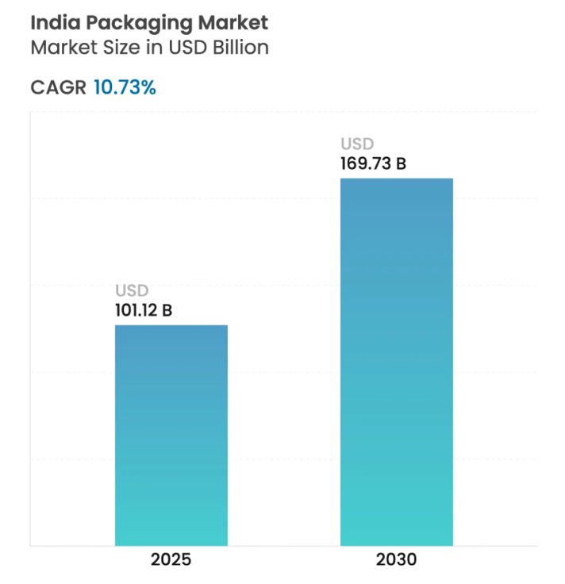
Source: Mordor Intelligence

Key growth opportunities include:
- Expansion of e-commerce packaging solutions.
- Growth of flexible packaging segment (fastest-growing segment)
- Increasing demand for sustainable packaging materials.
- Growth in food processing and pharmaceutical exports.
- Adoption of smart packaging technologies (QR, RFID, IoT-based tracking)
3.5. SWOT Analysis of the Packaging Industry in India
The Indian packaging materials industry is one of the fastest-growing industries in India and supports sectors such as FMCG, food processing, pharmaceuticals, agriculture, logistics, and e-commerce. Rising urbanization, changing consumer lifestyles, growth in organized retail, and increasing demand for packaged products are driving the growth of the industry. SWOT analysis helps in understanding the strengths, weaknesses, opportunities, and threats faced by the industry.

Strengths

Rapid Industry Growth:

India’s packaging industry is growing rapidly due to increasing consumption of packaged goods and the expansion of manufacturing sectors such as food & beverages, pharmaceuticals, FMCG, and e-commerce. The industry has witnessed significant growth in recent years and is projected to continue expanding at a strong pace. According to industry reports, the Indian packaging market was valued at approximately USD 101.12 billion in 2025 and is expected to reach around USD 169.73 billion by 2030, growing at a CAGR of nearly 10%-11%. This growth is mainly driven by rising urbanization, changing consumer lifestyles, increasing demand for convenience packaging, and the rapid growth of online retail and organized retail sectors.

Strong Demand from Multiple Industries:

Packaging materials are widely used in these sector:

FMCG

Food & Beverage

Pharmaceuticals

Agriculture

Cosmetics

E-commerce

The increasing demand from these sectors supports continuous industry growth.

Large Manufacturing Base:

India has more than 22,000 packaging units, and nearly 85% are small and medium enterprises (SMEs). This provides strong manufacturing capabilities and employment generation.

Technological Advancements:

The Indian packaging industry is adopting advanced technologies such as flexible packaging, smart packaging, digital printing, automation, AI, and IoT-based solutions. These innovations improve production efficiency, reduce costs, enhance product quality, and strengthen supply chain management. Smart packaging with QR codes and sensors is increasingly used in the food and pharmaceutical sectors, while sustainable packaging technologies promote the use of recyclable and eco-friendly materials.

Government Support:

Government initiatives such as the Make in India campaign, 100% FDI under the automatic route, and various MSME development schemes have encouraged investment and expansion in the Indian packaging industry. These policies have supported domestic packaging manufacturers in increasing production capacity, adopting modern technologies, and improving global competitiveness. Additionally, the government’s growing focus on environmental sustainability and restrictions on single-use plastics has encouraged innovation in eco-friendly and recyclable packaging alternatives, creating new growth opportunities for the industry.

- Weaknesses

- Environmental Concerns:
The packaging industry continues to face environmental challenges related to plastic waste, waste management, and carbon emissions. Increasing environmental awareness and government regulations are creating pressure on manufacturers to adopt sustainable, recyclable, and eco-friendly packaging alternatives.

- Dependence on Imported Inputs:
Despite having a strong domestic packaging industry, India still depends heavily on imported packaging machinery, specialty films, chemicals, and high-grade paper materials. This dependence increases production costs and makes the industry vulnerable to global supply chain disruptions and price fluctuations.

- Fragmented Industry Structure:
The Indian packaging industry is highly fragmented, with a large presence of small and unorganized manufacturers. This results in quality inconsistencies, limited economies of scale, lower operational efficiency, and challenges in achieving scalability for small and medium enterprises.

- High Capital Investment:
Advanced packaging technologies require significant investment in machinery, automation systems, and research & development. Setting up modern manufacturing facilities and managing high operational costs can be difficult for small businesses, reducing profitability and limiting technology adoption.

- Raw Material Price Fluctuations:
Frequent fluctuations in the prices of plastic resin, paper pulp, chemicals, and fuel increase production costs and negatively affect profitability, operational stability, and production planning in the packaging industry.

Opportunities

Sustainable Packaging Demand:

Growing consumer awareness and environmental concerns are increasing demand for recyclable, biodegradable, reusable, and paper-based packaging materials. This shift toward sustainable packaging creates major opportunities for innovation, investment, and growth for Indian packaging manufacturers.

Growth of E-commerce:

The rapid expansion of e-commerce platforms has increased demand for:
- Corrugated boxes
- Protective packaging
- Flexible packaging materials

Expansion of Food & Pharmaceutical Industries:

India’s food processing and pharmaceutical industries require advanced packaging solutions for hygiene, safety, and shelf-life extension.

Smart Packaging Technologies:

The integration of advanced technologies such as RFID tags, NFC, blockchain, QR code packaging, interactive labels, and temperature-sensitive packaging offers significant growth opportunities for the Indian packaging industry. These smart packaging solutions improve supply chain transparency, product tracking, consumer engagement, and product safety, especially in the food and pharmaceutical sectors.

Export Potential:

India is becoming a cost-effective global manufacturing hub for packaging materials and flexible packaging products. Its strong production capabilities and competitive manufacturing costs position the country as a preferred outsourcing destination for global packaging needs, especially in markets such as the U.S., Europe, Africa, and Southeast Asia.

Threats

Strict Environmental Regulations:

Government restrictions on single-use plastics and stricter recycling regulations may increase compliance costs for manufacturers.

Increasing Global Competition:

International packaging companies entering the Indian market increase competition for domestic manufacturers.

Supply Chain Disruptions:

Global supply chain issues and transportation challenges can affect raw material availability and increase costs.

Rising Energy Costs:

Packaging manufacturing requires significant energy consumption, and rising electricity and fuel prices directly affect production expenses.

Changing Consumer Preferences:

Consumers are increasingly preferring sustainable and minimal packaging solutions, forcing companies to continuously innovate.

3.6. PESTLE Analysis
PESTLE Analysis helps in understanding the external macro-environmental factors affecting the Indian packaging materials industry. It analyses Political, Economic, Social, Technological, Legal, and Environmental factors that influence industry growth and operations.
- Political Factors:
Government policies and regulations significantly influence the packaging industry, such as restrictions on single-use plastics, promotion of sustainable packaging initiatives, the Make in India campaign, MSME support schemes, 100% FDI under the automatic route, and export promotion policies. These government initiatives encourage investment, domestic manufacturing, and industrial expansion, while environmental regulations push companies toward eco-friendly and recyclable packaging solutions.

- Economic Factors:
Economic growth, rising disposable income, expansion of FMCG, retail, and e-commerce sectors, along with industrial growth and export opportunities, are increasing demand for packaging materials in India. However, inflation and raw material price fluctuations also affect industry costs and profitability.

- Social Factors:
Changing consumer lifestyles, increasing urbanization, and growing awareness regarding hygiene and convenience are significantly influencing the packaging materials industry. Consumers are increasingly preferring packaged and ready-to-use products due to busy lifestyles and rising health consciousness. Attractive packaging, innovative designs, and brand-oriented packaging also influence customer purchasing decisions. In addition, increasing environmental awareness among consumers has increased demand for sustainable, recyclable, and biodegradable packaging solutions, especially in FMCG, food & beverage, and cosmetics sectors.

- Technological Factors:
Technological advancements are transforming the packaging industry through automation, smart packaging, digital printing, and advanced manufacturing technologies. Companies are increasingly adopting technologies such as QR codes, RFID tracking systems, and smart labeling to improve product traceability, inventory management, and customer engagement. Innovations in flexible packaging, lightweight materials, biodegradable packaging, and barrier technologies are helping improve product shelf life, reduce transportation costs, and enhance operational efficiency. Automation and Industry 4.0 practices are also improving productivity and reducing wastage in manufacturing processes.

- Legal Factors:
The packaging industry is highly regulated due to increasing concerns regarding consumer safety, environmental protection, and waste management. Companies must comply with various laws and regulations related to packaging standards, labeling requirements, food safety, and plastic waste management. Regulations such as Plastic Waste Management Rules, FSSAI guidelines, Bureau of Indian Standards (BIS) specifications, and environmental protection laws directly affect packaging material selection and manufacturing practices. Non-compliance with legal requirements may lead to penalties, product recalls, and reputational risks for companies.

- Environmental Factors:
Environmental sustainability has become one of the most important factors affecting the packaging materials industry. Excessive use of plastic packaging and increasing packaging waste have raised concerns regarding pollution, landfill accumulation, and carbon emissions. As a result, companies are increasingly shifting toward eco-friendly alternatives such as recyclable paper packaging, biodegradable plastics, reusable containers, and compostable materials. Government regulations, environmental activism, and growing consumer awareness are encouraging businesses to adopt sustainable packaging practices and reduce environmental impact. The industry is also focusing on improving recycling efficiency, reducing material wastage, and supporting circular economy initiatives.

Chapter 4: Types of Packaging Materials

The packaging materials market is divided into different material types based on durability, flexibility, cost, and application. Paper packaging is widely used for eco-friendly solutions, while plastic dominates due to its lightweight and versatile nature. Glass and metal packaging provide strong protection and are commonly used for premium and food products. Flexible packaging is gaining popularity because of convenience and low transportation cost. The food and beverage sector holds the largest market share, showing strong demand for safe and sustainable packaging solutions across industries.

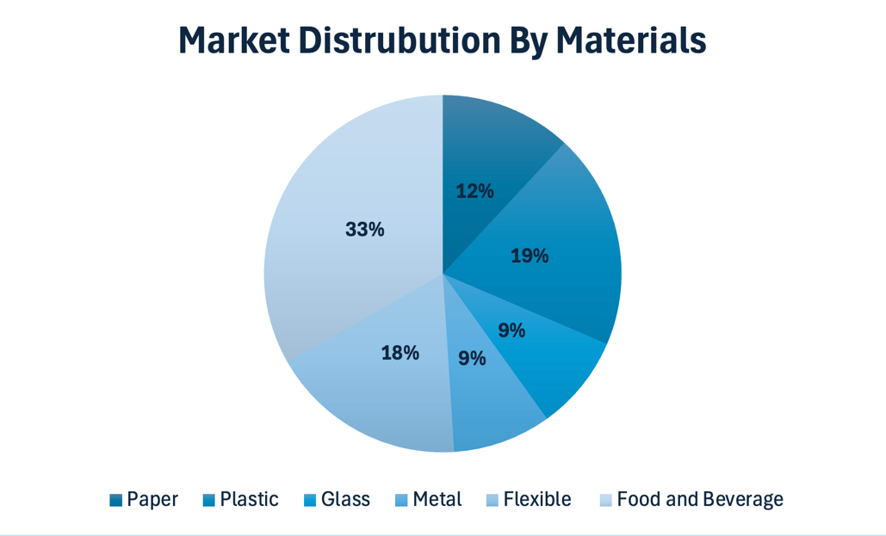

  - Paper Packaging
Paper and paperboard packaging is one of the fastest-growing segments in the packaging industry due to increasing environmental awareness, government restrictions on plastic usage, and rising demand for sustainable packaging solutions. These packaging materials are widely used in e-commerce, food packaging, retail products, and transportation packaging because they are recyclable, biodegradable, lightweight, and cost-effective.
According to industry estimates, the India paper and paperboard packaging market is valued at approximately USD 13.72 billion in 2025 and is expected to grow to around USD 19.57 billion by 2031, at a CAGR of 6.13% during the forecast period. The market is also projected to reach USD 14.54 billion in 2026, reflecting steady growth in demand for paper-based packaging materials.
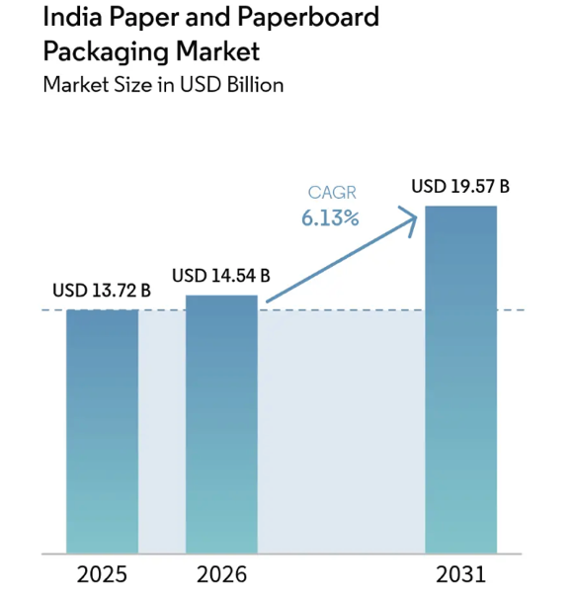
Source: Mordor Intelligence

The growth of this segment is mainly driven by:
- Expansion of e-commerce and retail sectors
- Increasing demand for sustainable packaging
- Government regulations on plastic usage
- Growth in food delivery and FMCG industries
- Rising consumer preference for eco-friendly packaging
Paper and corrugated packaging are increasingly preferred by companies due to their recyclability, lower environmental impact, and suitability for branding and transportation purposes.

Glass Packaging
Glass packaging is one of the most widely used packaging materials in industries such as beverages, pharmaceuticals, cosmetics, perfumes, and food products due to its high safety standards, premium appearance, and excellent preservation properties. Glass packaging mainly includes bottles, jars, containers, and vials used for storing and transporting products safely. One of the major features of glass packaging is that it is chemically inert and non-reactive, which helps maintain product purity, taste, and quality for a longer period. In addition, glass is 100% recyclable and reusable, making it an environmentally sustainable packaging material.

Glass packaging is highly preferred in the beverage industry for products such as soft drinks, juices, alcoholic beverages, and dairy products because it protects products from contamination and preserves freshness. In the pharmaceutical industry, glass containers and vials are widely used for medicines, syrups, and injections due to their hygienic and non-reactive properties. Similarly, the cosmetics and perfume industries use glass packaging to provide a premium and attractive appearance to products.

The major advantages of glass packaging include excellent barrier protection against moisture, air, and chemicals, preservation of product quality, recyclability, and premium product presentation. However, glass packaging also has certain limitations such as higher manufacturing costs, fragile nature, and increased transportation expenses due to its heavy weight compared to plastic and flexible packaging materials.
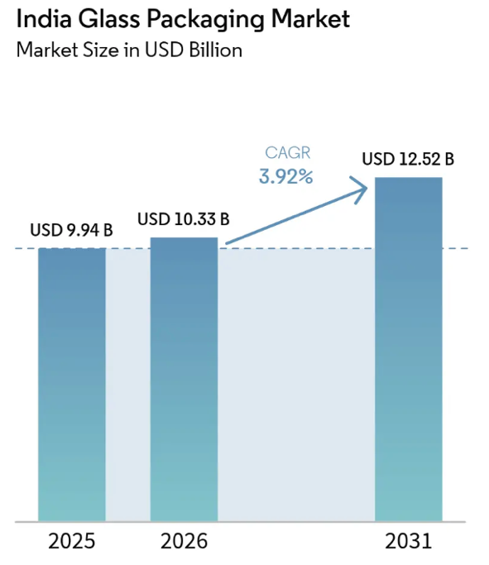
Source: Mordor Intelligence

The growth of the glass packaging market is mainly driven by increasing demand for premium beverages, expansion of pharmaceutical and cosmetics industries, rising consumer preference for sustainable packaging, and growing awareness regarding recyclable packaging materials. Increasing focus on eco-friendly packaging solutions and higher demand for premium product presentation are also expected to support long-term market growth in the coming years.

Metal Packaging
Metal packaging is widely used in industries such as food & beverages, pharmaceuticals, cosmetics, and industrial products due to its strength, durability, and long shelf-life protection. Metal packaging mainly includes aluminium cans, steel containers, aerosol cans, and metal drums used for safe storage and transportation of products.
Metal packaging is highly preferred because it provides excellent barrier protection against moisture, air, light, and contamination. In addition, metal materials are recyclable and reusable, making them suitable for sustainable packaging initiatives.
According to industry estimates, the India metal packaging market is valued at approximately USD 10.23 billion in 2025 and is expected to grow to around USD 14.24 billion by 2031, at a CAGR of 5.68% during the forecast period. The market is projected to reach USD 10.81 billion in 2026, indicating steady growth in demand for metal packaging solutions.
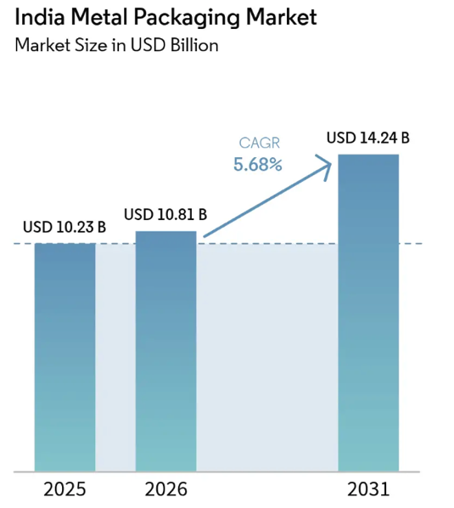
Source: Mordor Intelligence

The growth of the metal packaging market is mainly driven by:
Increasing demand for canned food and beverages
Growth in pharmaceutical and aerosol packaging
Rising focus on recyclable packaging materials
Expansion of FMCG and industrial sectors
Longer shelf-life requirements for products
Metal packaging continues to witness stable demand due to its durability, recyclability, and ability to preserve product quality for longer periods.

Plastic Packaging
Plastic packaging is one of the most widely used packaging materials in India due to its lightweight nature, flexibility, durability, and cost-effectiveness. It is extensively used across industries such as FMCG, food & beverages, pharmaceuticals, healthcare, cosmetics, and e-commerce. Plastic packaging includes bottles, containers, pouches, films, wraps, trays, and sachets used for product storage, transportation, and protection.

One of the major features of plastic packaging is its excellent barrier protection against moisture, leakage, and contamination. Plastic packaging is also easy to mold into different shapes and sizes, making it suitable for mass production and branding purposes. Flexible plastic packaging is particularly gaining popularity because it reduces transportation and storage costs.

The major advantages of plastic packaging include low production cost, high durability, lightweight structure, flexibility, and convenience in handling. However, increasing environmental concerns regarding plastic waste and pollution have become major challenges for the industry. Government regulations related to single-use plastics and recycling requirements are encouraging companies to adopt recyclable and sustainable plastic packaging solutions.
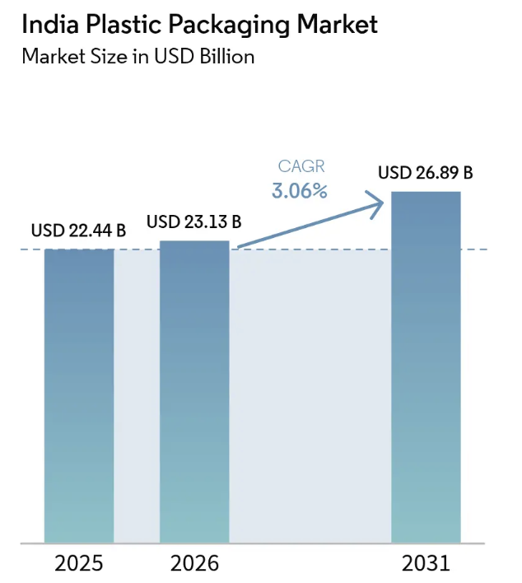
Source: Mordor Intelligence

The growth of the plastic packaging market is mainly driven by:

- Rising demand from FMCG and food industries
- Expansion of e-commerce and logistics sectors
- Increasing use of flexible packaging solutions
- Growth in pharmaceutical and healthcare packaging
- Cost-effectiveness and convenience of plastic materials

In India, flexible plastic packaging accounts for a major market share due to its lower transportation cost and suitability for packaged food, personal care, and pharmaceutical products. The industry is also witnessing increased adoption of recycled-content plastics and sustainable packaging technologies to comply with environmental regulations.

Chapter 5: Major Companies Analysis

The Indian packaging industry consists of both large, organized players and a significant number of small and medium enterprises (SMEs). Major companies in the sector operate across flexible packaging, plastic packaging, paperboard packaging, specialty films, and sustainable packaging solutions. These companies play a crucial role in supporting industries such as FMCG, pharmaceuticals, food & beverages, cosmetics, and e-commerce.
The financial performance of leading packaging companies indicates steady growth in revenue and profitability due to increasing demand for packaged products, technological advancements, and expansion in domestic and international markets. Companies are also focusing on sustainable packaging, automation, and innovation to strengthen their market position and improve operational efficiency.

Among the major players, UFlex Ltd. remains one of the largest packaging companies in India with strong growth in revenue from ₹46,554 crore in FY21 to ₹78,096 crore in FY25. The company recorded a revenue growth rate of 17.41% with a CAGR of 10.90%, reflecting strong expansion across flexible packaging and specialty films. The company earned a net profit of ₹214.45 crore in FY25.

Huhtamaki India Ltd. reported relatively stable revenue performance, though the company witnessed slight decline in recent years due to changing market conditions and cost pressures. The company generated revenue of ₹24,694.10 crore in FY25 with a net profit of ₹118.16 crore.

EPL Ltd. demonstrated steady financial growth with revenue increasing from ₹3,106.10 crore in FY21 to ₹4,256.90 crore in FY25. The company also reported a strong profit margin of 8.49%, indicating efficient operational performance in specialty packaging products.

TCPL Packaging Ltd. recorded one of the strongest growth rates among the selected companies. Revenue increased from ₹906.37 crore in FY21 to ₹1,711.83 crore in FY25, with a CAGR of 13.56% and profit margin of 8.25%, reflecting strong demand for paperboard and printing packaging solutions.

Jindal Poly Films Ltd. also showed significant growth due to rising demand for specialty films and flexible packaging products. The company recorded revenue of ₹5,742.37 crore in FY25 with a revenue growth rate of 30.40%.

Major Packaging Companies Financial Analysis

Company | Headquarters | Revenue FY25 (₹ Cr) | Net Profit FY25 (₹ Cr) | Revenue Growth % | CAGR % | Profit Margin %
UFlex Ltd. | Noida | 78,096.00 | 214.45 | 17.41 | 10.90 | 0.27
Huhtamaki India Ltd. | Thane | 24,694.10 | 118.16 | -2.05 | -1.22 | 0.48
EPL Ltd. | Mumbai | 4,256.90 | 361.60 | 7.08 | 6.51 | 8.49
TCPL Packaging Ltd. | Mumbai | 1,711.83 | 141.27 | 14.29 | 13.56 | 8.25
Jindal Poly Films Ltd. | Gurugram | 5,742.37 | 109.79 | 30.40 | 6.33 | 1.91

Overall, the major companies in the Indian packaging industry are focusing on capacity expansion, sustainable packaging technologies, innovation, and export growth to strengthen their competitive position. Increasing demand from FMCG, food processing, pharmaceuticals, and e-commerce industries is expected to support future growth of these companies.

5.1. Revenue Analysis of Major Packaging Companies

The revenue comparison of major packaging companies highlights the dominance of UFlex Ltd. in the Indian packaging industry. With revenue of ₹78,096 crore in FY25, UFlex Ltd. significantly outperformed all other selected companies due to its strong presence in flexible packaging, specialty films, and global operations.

Huhtamaki India Ltd. secured the second position with revenue of ₹24,694.10 crore, supported by its strong presence in food and consumer packaging solutions. Jindal Poly Films Ltd. generated revenue of ₹5,742.37 crore, reflecting growth in specialty films and flexible packaging demand.

EPL Ltd. reported revenue of ₹4,256.90 crore, demonstrating stable performance in laminated tube packaging products, while TCPL Packaging Ltd. generated ₹1,711.83 crore, showing consistent growth in paperboard and printing packaging solutions.

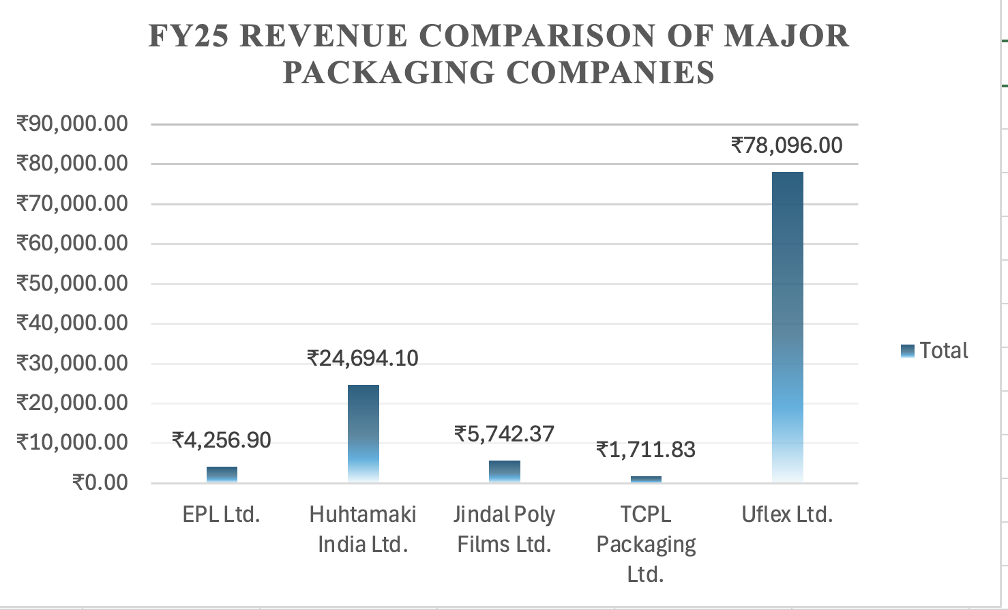

5.2. Market Share Analysis

The market share analysis indicates that UFlex Ltd. dominates the selected packaging companies with the largest share due to its diversified packaging portfolio and international operations. Huhtamaki India Ltd. also maintains a strong market position in food and consumer packaging segments.

Jindal Poly Films Ltd., EPL Ltd., and TCPL Packaging Ltd. hold comparatively smaller market shares but continue to strengthen their market presence through product innovation, sustainable packaging, and expansion strategies.

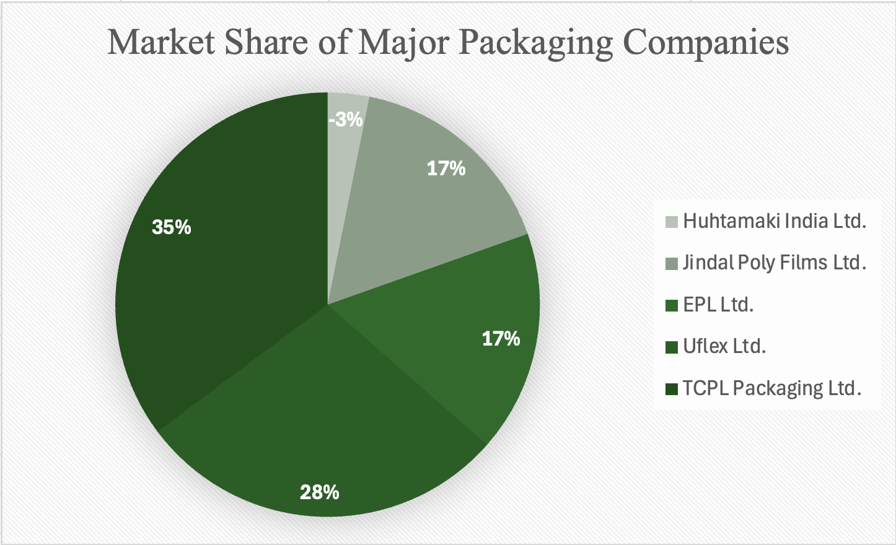

5.3. Growth and CAGR Analysis

The CAGR comparison reflects the growth potential of the selected packaging companies over the study period. TCPL Packaging Ltd. recorded the highest CAGR of 13.56%, indicating rapid expansion and increasing market demand for paperboard packaging products.

UFlex Ltd. achieved strong CAGR growth of 10.90%, supported by export growth and increasing demand for flexible packaging. EPL Ltd. and Jindal Poly Films Ltd. maintained moderate but stable growth rates of 6.51% and 6.33% respectively.

Huhtamaki India Ltd. recorded a negative CAGR of -1.22%, mainly due to market challenges, rising input costs, and fluctuating demand conditions.
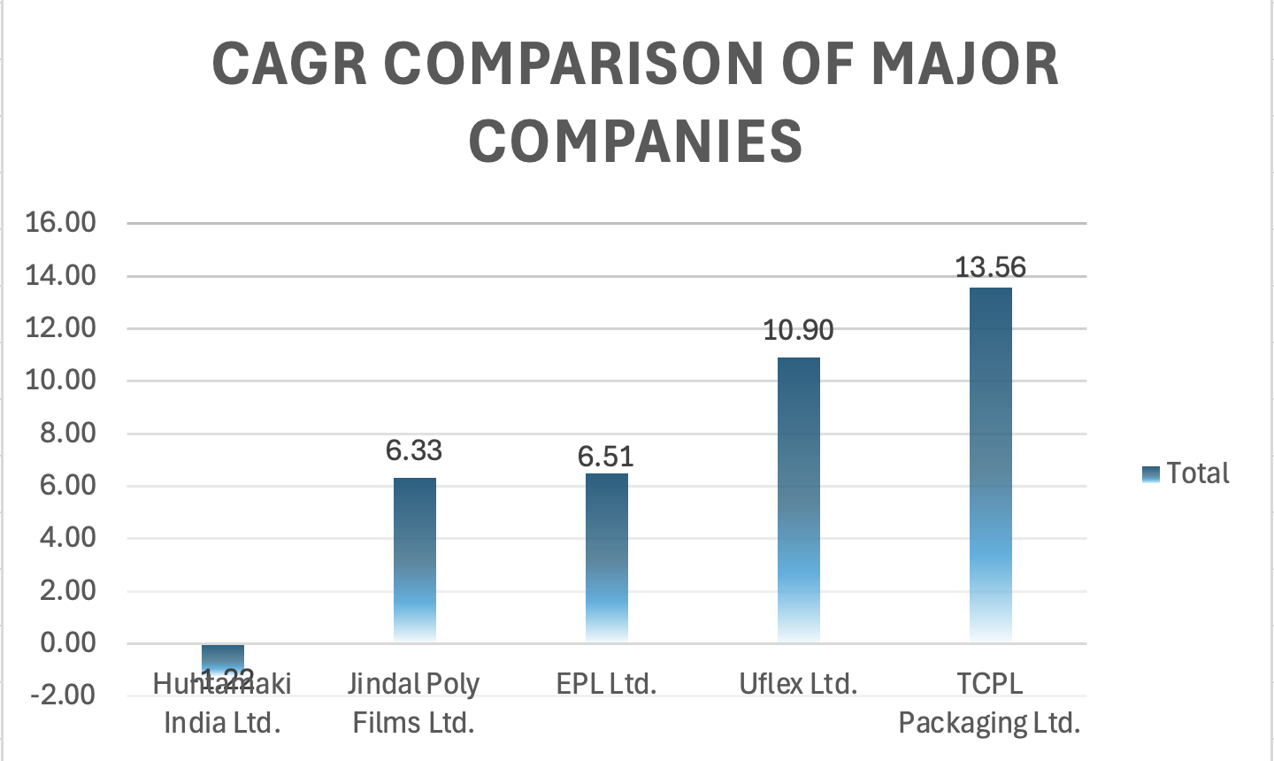

5.4. Key Findings

- UFlex Ltd. is the market leader among the selected companies in terms of revenue size.
- TCPL Packaging Ltd. recorded the highest CAGR among the selected companies.
- EPL Ltd. reported the highest profit margin percentage.
- The industry remains highly competitive and fragmented despite the presence of large organized players.
- Sustainable packaging and flexible packaging segments are driving future growth opportunities.

The Indian packaging industry is expected to witness significant growth in the coming years due to increasing demand from FMCG, food processing, pharmaceuticals, and e-commerce sectors. Major companies are focusing on innovation, automation, sustainable packaging technologies, and export expansion to strengthen their competitive position.

Among the selected companies, UFlex Ltd. continues to dominate the market in terms of revenue and operational scale, while TCPL Packaging Ltd. demonstrates the strongest growth potential through its high CAGR. Companies such as EPL Ltd. and Jindal Poly Films Ltd. are maintaining stable growth through niche packaging solutions and specialty product offerings.

Overall, the industry offers strong future opportunities driven by rising consumer demand, technological advancement, and increasing focus on environmentally sustainable packaging solutions.

Chapter 6: Challenges in Packaging Industry

- Rising raw material prices
- Environmental concerns and plastic waste
- Strict government regulations
- High cost of sustainable packaging
- Recycling and waste management issues
- Technological investment requirements
- Intense market competition
- Supply chain and logistics challenges
- Changing consumer preferences
- Compliance with legal and quality standards

Chapter 7: Future Trends
- Smart packaging technologies
- AI-based packaging systems
- QR code-enabled packaging
- Automation and robotic packaging
- Sustainable and eco-friendly packaging
- Biodegradable packaging materials
- Digital printing technologies
- Lightweight packaging solutions
- IoT-enabled packaging tracking
- Recyclable and reusable packaging
- Personalized packaging designs
- Advanced supply chain integration

Chapter 8: Conclusion & Recommendations
The packaging materials industry is one of the fastest-growing industries supporting sectors such as FMCG, food & beverages, pharmaceuticals, retail, and e-commerce. Increasing demand for packaged products, technological advancements, and growth in organized retail and online shopping have significantly contributed to industry growth. The industry is also shifting toward sustainable and eco-friendly packaging solutions due to rising environmental concerns and government regulations.
The future scope of the packaging industry is highly promising with the growth of smart packaging, automation, AI-based technologies, and biodegradable packaging materials. Increasing consumer awareness regarding hygiene, convenience, and sustainability is expected to further drive market demand.
To achieve long-term growth, packaging companies should focus on sustainable packaging solutions, technological innovation, automation, and efficient waste management systems. Investment in research and development and compliance with environmental regulations will also help companies remain competitive in the market.
Overall, the packaging materials industry is expected to continue growing steadily in the coming years due to rising industrial demand, technological advancements, and increasing focus on sustainability and innovation.
References:
- India Packaging Market Size & Share Analysis - Growth Trends and Forecast (2025 - 2031) Source: https://www.mordorintelligence.com/industry-reports/packaging-industry-in-india
- https://businessesranker.com/swot-analysis-of-the-packaging-industry-in-india/
- IBEF https://www.ibef.org/industry/paper-packaging
- India Packaging Market Size, Share and Growth Report
Source: https://www.fortunebusinessinsights.com/india-packaging-market-114065
- https://www.ibef.org/download/1778154998_Paper-and-Packaging-February-2026.pdf
- Statista – Global Production Volume of Paper and Plastic Packaging Materials (2021–2028 Forecast)
- https://www.mordorintelligence.com/industry-reports/india-plastic-packaging-market
- https://www.mordorintelligence.com/industry-reports/india-glass-packaging-market
- https://www.mordorintelligence.com/industry-reports/india-metal-packaging-market
- https://www.mordorintelligence.com/industry-reports/india-paper-and-paperboard-packaging-market
- Uflex Ltd.: https://www.uflexltd.com/pdf/financials/annual-reports/UFLEX-AR-2024-25.pdf
- Huhtamika Ltd.: https://www.huhtamaki.com/globalassets/flexible-packaging/india/investors-india/annual-reports/2025/hil-ar-2025-spread.pdf
- EPL Ltd.: https://www.moneycontrol.com/financials/epl/consolidated-profit-lossVI/ep11/1#ep11
- Jindal Poly Films Ltd.: https://www.moneycontrol.com/financials/jindalpolyfilms/consolidated-profit-lossVI/jpf01
- TCPL Ltd.: https://www.moneycontrol.com/financials/tcplpackaging/profit-lossVI/tcp01

